Custom Physics Engine

Authored by Ethan Moffatt

# Features

* 3d collisiondetection, both homogeneous and heterogeneous, between the following primitives:
  + Sphere
  + Axis-Aligned Bounding Box
  + Plane
* Collision resolution using both static and dynamic rigid-bodies.

# Future Improvements

* Expanded collision-shape support, including:
  + Oriented Bounding Box
  + Ray casting
  + Capsule
  + Convex Mesh
  + Concave Mesh
* Kinematic rigid-body support.
* Swept collision detection support.
* Spring and Joint simulation.

# Third-Party Libraries

* *OpenGL Mathematics (GLM) C++ SDK*. Licensed under the ***Happy Bunny License*** (Modified MIT License).

<https://github.com/g-truc/glm>

**For demonstration purposes:**

* *aieBootstrap*. C++ OpenGL wrapper. Licensed under the ***MIT License***.

<https://github.com/AcademyOfInteractiveEntertainment/aieBootstrap>

# Research References

* Rigid-body dynamics resolution algorithm.

<http://chrishecker.com/Rigid_body_dynamics>

Subsection: Physics, Part 4: The Third Dimension. Page: 9/10.

# Class Diagram

[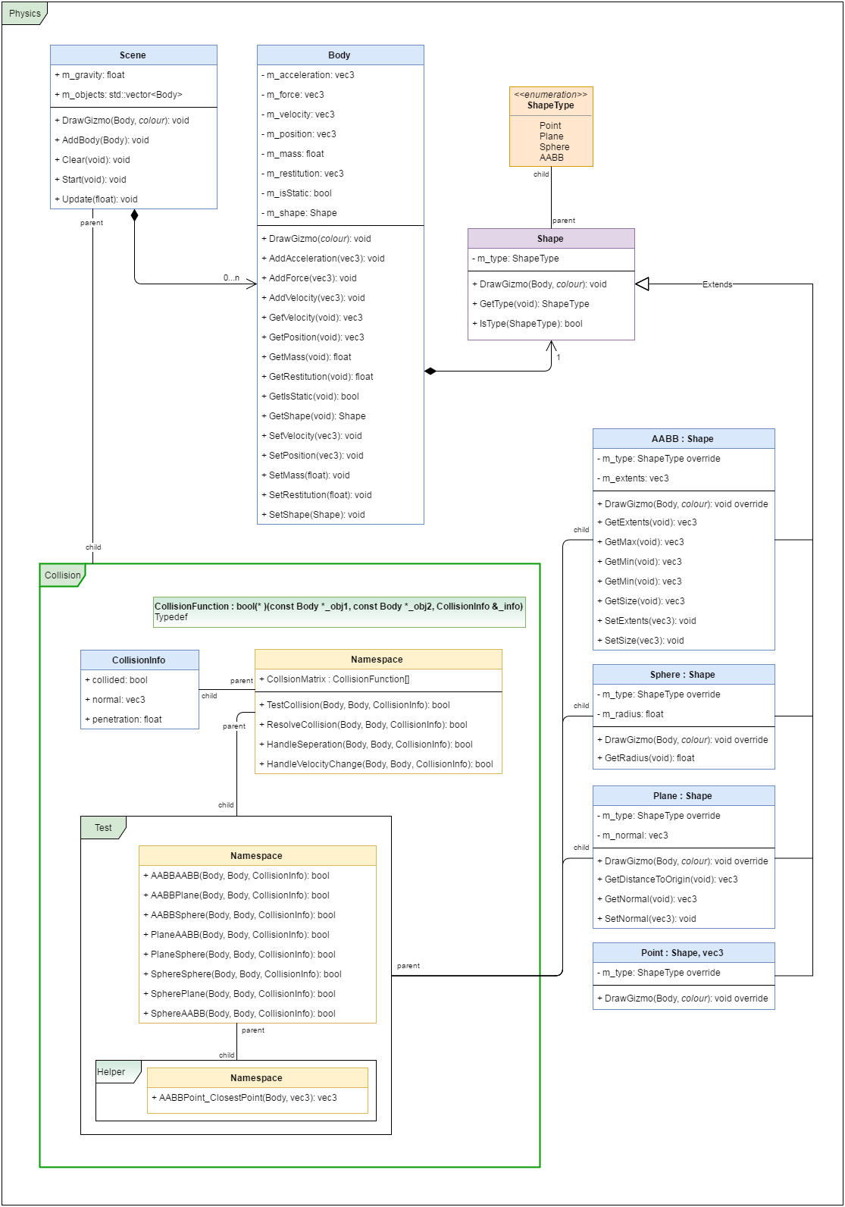](https://www.draw.io/#HDarker1300%2FPhysics_2017%2Fmaster%2FCustom%20Physics%20Engine%20-%20Class%20Diagram.xml)